Chess Pieces
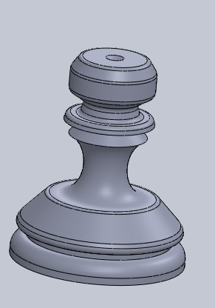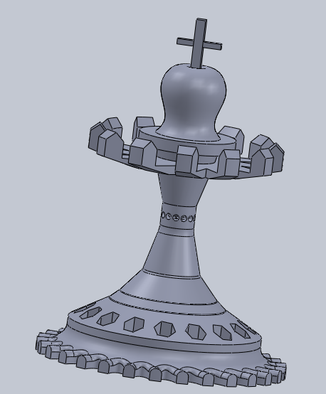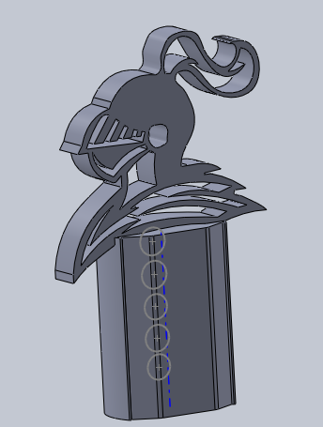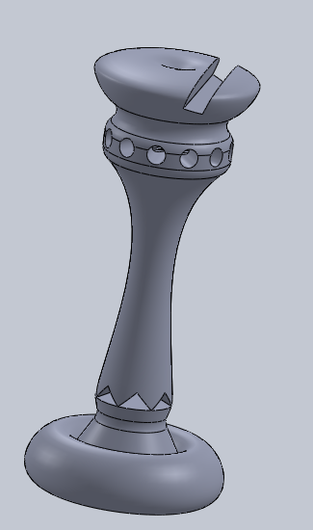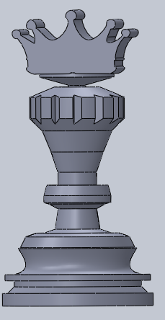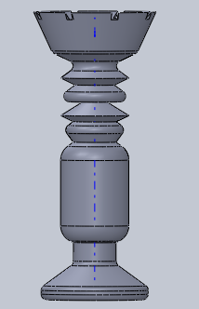

Group Name (if applicable)
Paul Lopez
Cedarcrest High School
Date
- Introduction (2 points)
  - Introduction paragraph(s) gives an overview of the project. Tell what the project is in general and specific terms. The project I decided to do is all 6 different types of chess pieces such as the Pawn, Queen, King, Bishop, Rook, and Knight and tried to make them all look unique and different than the original chess pieces.

- Target Market (2 points)
  - Give a description of who would use the product and / or a customer list. (It could be a design for one specific user.) My products are aiming for customers that want something that’s a little different, and newer generation of chess players which I’m sure they got bored of the same old chess pieces.

- Success in Creating Product (16 points)
  - Answer the question: How successful were you in creating the product?
  - Give lessons learned (at least 2). Such as what you would do again (2). What you would not do again (2). I was pretty successful doing this assignment, I did everything in a week or less and I learned how to use circular linear pattern and spline. I would totally do this project because it was really fun getting to make your own chess pieces.

  - Give specific and appropriate supporting details (12). Use as many paragraphs as needed to fully explain. (You may also embed screen shots.) I used circular linear pattern to make the extruded cut for making my kings cross and supports. I also used spline to make every round surface as perfect as I could.

- Product Sketches and Ideas (8 points)
  - Along with the sketches, you need to talk about the ideas that led to the sketches. The sketches themselves are worth 2 points of the 8 for the section.
  - Describe how you decided on the project (2), what requirements you decided on (2), and how you met those requirements with your design (2). 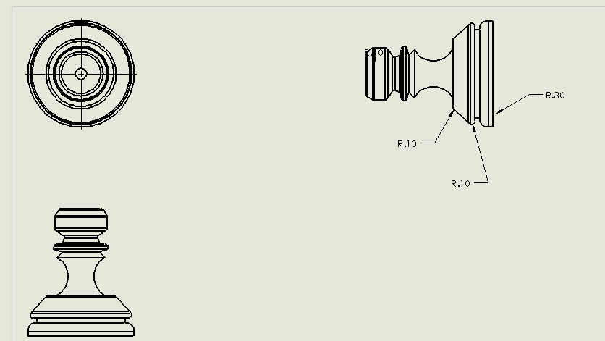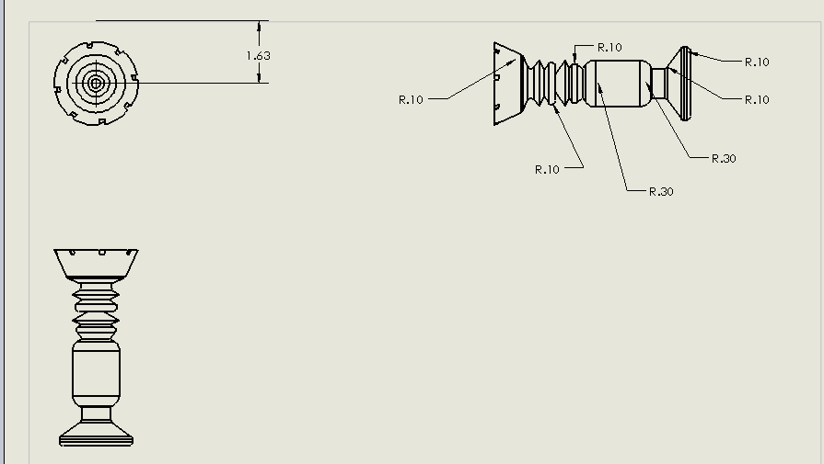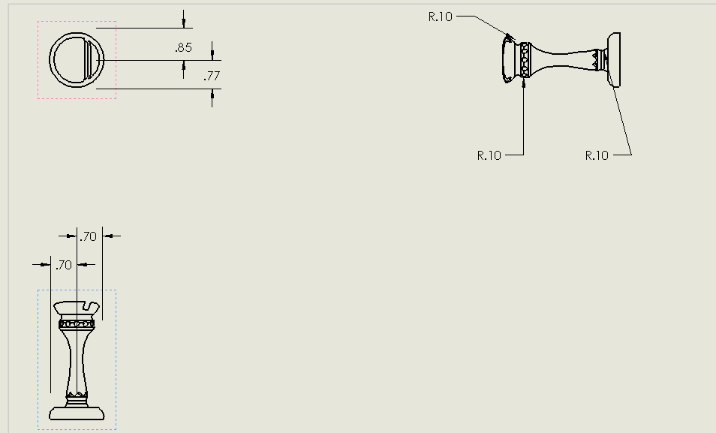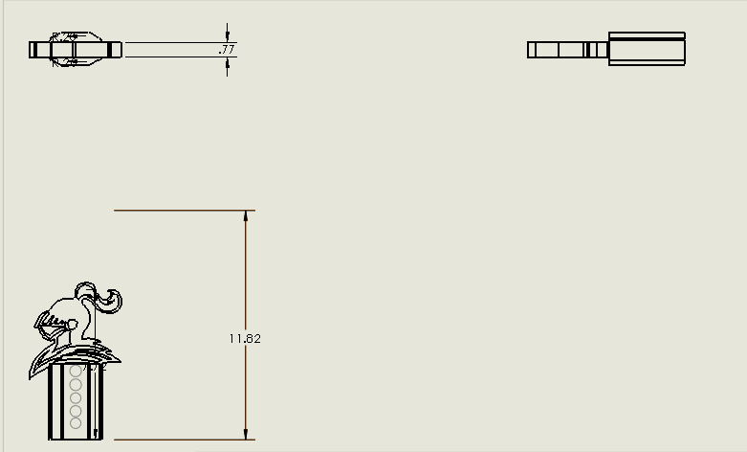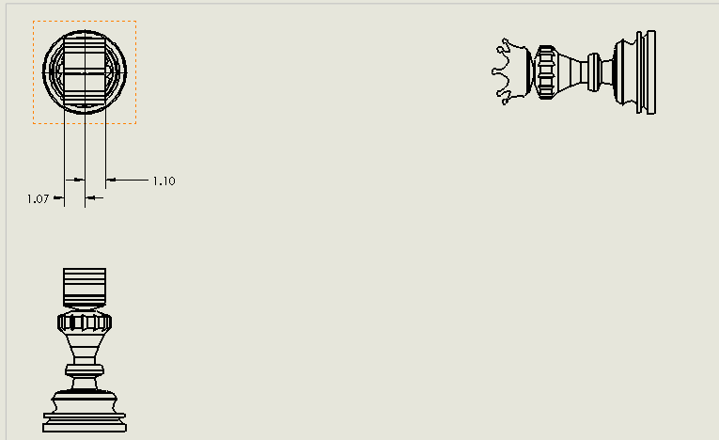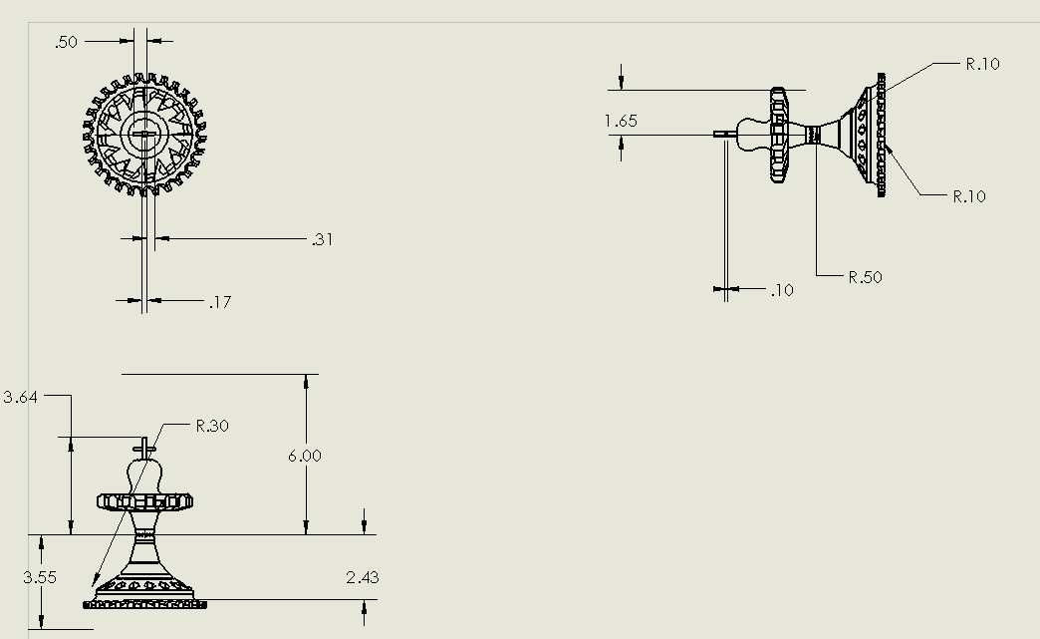

- Product Drawings (8 points)
  - You need product drawings (6 points). Along with the drawings, give some explanation of what the drawings are (2). My drawings are a representation of the work I did and how I dimensioned everything.

- Product Renderings and/or Physical Models (4 points)
  - Put together enough renderings to show off your product. (3) These renderings (and /or pictures of physical models) must show case the product in the best light for customers or potential customers to want to obtain the product. Also give a short explanation of how you would go about appealing to customers (1).
Appendix/Notes

You can put other notes or thoughts into the Appendix/Notes section. These are thoughts or notes that do not fit into the other categories but add to the understanding of the product. The Appendix/Notes section may be deleted if not used.

By the way, edit the header (put the title of your project) and footer (replace “Name” with your name so that it appears on each page).

